Teaching Character Project - KS4 English

Scheme of Work – Teaching Character Through Developing Speaking and Listening Skills

The aim of this scheme of work is to improve attainment in Speaking and Listening through the identification of, valuation of and application of Aristotlean virtues. Therefore, the outcomes should include:

- Improved performance at Speaking and Listening.
- Recognition of the benefit of using Ariostotlean virtues in discussions.
- Development of the ability to apply Aristotlean virtues in discussions.

Although JCQ have not yet issued guidance on the assessment criteria for speaking and listening, the core of speaking and listening has always required a demonstration of thoughtful and considered response. This scheme of work is built around that principle.

The pictures used in the scheme of work are free, however teachers may prefer to use cut up images from magazines etc.

Lesson 1

Learning objective; to develop understanding of useful virtues for speaking and listening tasks
Resources; definitions/ self assessment sheet, virtues chart (perseverance, respect, community mindedness, dignity), paper, https://www.youtube.com/watch?v=IXNKyzGgoZc&spfreload=10
depending on how much time you have, and the ability level of your group.
Differentiation; the virtues chart is scaffolded to support lower ability (A and B)

Starter – Hand out the definitions/ self assessment sheet. Go through the definitions and students to self assess using SWOT. Point out to the students that each virtue can appear more than once, for example, ‘perseverance’ might be a weakness if you recognise that you give up easily, but also an opportunity to improve and develop. For each point on the chart, write down an example. E.g. ‘I show community mindedness by helping at home.’

Main – Hand out the ‘virtues’ sheet (either A or B depending on ability). Show the debate on youtube, students to complete the sheet while watching
Q – How did using the virtues affect the outcomes of the debate? Students to use Think, Pair, Share (think on your own for a few minutes, discuss in pairs, share with the class).

Plenary – Students to begin to produce a guide to performing in a debate/ discussion using the virtues identified. Give each virtue a heading in the guide with examples of how to apply it, and what the benefit is of each to speaking and listening.

Lesson 2

Learning objective; to develop understanding of how to reach consensus
(Civic virtue – community mindedness)
Resources; Sets of pictures cut up into jigsaw style pieces with one piece from each put into another set. (credit: http://www.freeimages.co.uk/), scrap paper, debate worksheet, Youtube clip https://www.youtube.com/watch?v=rIfoIkJzlxU

You can use the pictures in this pack, or use your own that may fit with your debate topic.

Differentiation; by resource – the debate worksheet is differentiated.

Starter – Groups of 4. Hand out the sets of pictures, one pack to each group, tell them that the first group to make the whole picture with the pieces they have, wins. Give them 5-10 minutes. After this period explain that no one could win (unless they cooperated with other groups). Groups to make notes on scrap paper about how it felt. Feedback – how could it be different? (Work towards sharing resources, helping each other out, in order for everyone to achieve) How can we apply this thinking to taking part in debates?

Main – Hand out consensus worksheet. Show the youtube clip on consensus decision making– students to complete questions on sheet while watching.

Plenary; Add to the guide that you began last lesson

AT THIS POINT THE TEACHER NEEDS TO IDENTIFY AN ISSUE FOR DEBATE PRIOR TO LESSON 3. THIS MAY BE A SCHOOL ISSUE, LOCAL ISSUE, OR GLOBAL ISSUE. WHATEVER YOU FEEL WILL BE RELEVANT AND INTERESTING FOR YOUR STUDENTS. Whatever you choose, it should be an issue that requires collaboration so that students have to apply community mindedness in order to resolve the issue.

Lesson 3

Learning objective; to develop understanding of working together to sustain discussion through persistence and community mindedness.
Resources; large piece of backing paper
Differentiation; Consider groups here – placing weaker students with stronger would be beneficial here, but consider giving each student a number of contributions they have to make.

Starter; students to work in groups of 3 writing down words and phrases that open, sustain and conclude discussions.

Main; Number students 1-3. 1s are to think of all the ways of opening a discussion that they can, 2s are to think of all the phrases that can be used to sustain a discussion, 3s to think of all the ways of moving discussions towards reaching consensus.

All students to complete their section on the backing paper – openers, sustainers and concluders.

Plenary; introduce the issue to be debated. Divide the class into 2, one in favour, one against. The class will remain in these groups for the rest of the scheme of work. Divide each half up into smaller groups of 4 or 5 to start brainstorming their arguments. Make sure that you have the same number of groups on each side of the debate so that you will be able to pair them up against each other.

Home learning: Research homework – find facts, figures, evidence to support your group’s point of view.

Lesson 4

Learning objective; to develop understanding of ways of structuring and sustaining debate to reach consensus.
Resources; the huge sheet developed in the previous lesson, on display. A win-win sheet
Differentiation; expert groups should be deliberately mixed ability to support weaker students with the subject knowledge, and stronger students with their development of community mindedness.

Starter; Class to work in their groups from last lesson. Groups to share their findings from their home learning and look at ways at working their research into openers, sustainers and ways of reaching consensus.

Main; blending onwards from the starter, when groups are ready ask them to begin to anticipate what the opposing point of view might be, and what compromises they could offer. Work into ways of reaching consensus.

Plenary; in the expert group complete the win-win sheet. What could you offer, what could they offer, what would be the benefit to others.

Lesson 5

Learning objective; to develop the ability to apply and reflect upon the virtues to support debate.
Resources; assessment and self assessment sheet. Cameras/ phones if you want to use this for official assessment, work from previous lessons. SWOT analysis completed in lesson 1.
Differentiation; by outcome

Give out the assessment sheets. Students to put their names on them.

Pair up each group with a group from the other side of the debate. You can have 2 sets of groups debating at once, so long as your classroom is big enough for them not to disturb each other.

The students not yet debating are now observers. The students debating should give their assessment sheet to an observer to assess them in the debate.

Using the openers, sustainers and concluders, and their win-win sheet, the debaters should now discuss the issue with a time limit of 15 minutes to reach consensus.

After 15 minutes the observers should give the debaters back their assessment sheets, swap places with the debaters, and give their own assessment sheet to one of the new observers. Now the new debaters need to use the openers, sustainers and concluders, and the win-win sheets to aim to reach consensus in 15 minutes. The new observers are to assess them and return the assessment sheet at the end.

Plenary; all students to complete the self assessment section on their sheet, and then review and finally add to their SWOT analysis from lesson 1. Exit question – what conclusions can we reach as a class?
Definitions/ self assessment sheet
A virtue is part of our character – a part that helps us to feel in the right way, about the right things, towards the right people, at the right time, for the right reasons. Our key virtues to bear in mind for our speaking and listening are perseverance, respect, community mindedness and dignity.

Perseverance is when you keep on trying.
Respect is when you remain polite to others, and consider their feelings.
Community mindedness is when you want, and work towards, the best for your community.
Dignity is when you stay formal, even when you have very strong feelings.

Now consider your own strengths, weaknesses, opportunities and threats in relation to these virtues – place them where you think they are for you in this table. Give examples of when this has been an important virtue for you.

Strengths | Weaknesses
Opportunities | Threats
Virtues Chart A
You are now going to watch a debate being set up.
How was perseverance demonstrated? Give an example

How was respect demonstrated? Give an example

How was community mindedness demonstrated? Give an example

How was dignity demonstrated? Give an example

How did the virtues help in the debate?

Virtues Chart B
You are now going to watch a debate being set up.
Give an example of when one person asked another a question. Which of the virtues does this relate to?

Give an example of when one person said something positive about another. Which of the virtues does this relate to?

What are they all trying to achieve? Which of the virtues does this relate to?

How did the virtues help in the debate?

Pictures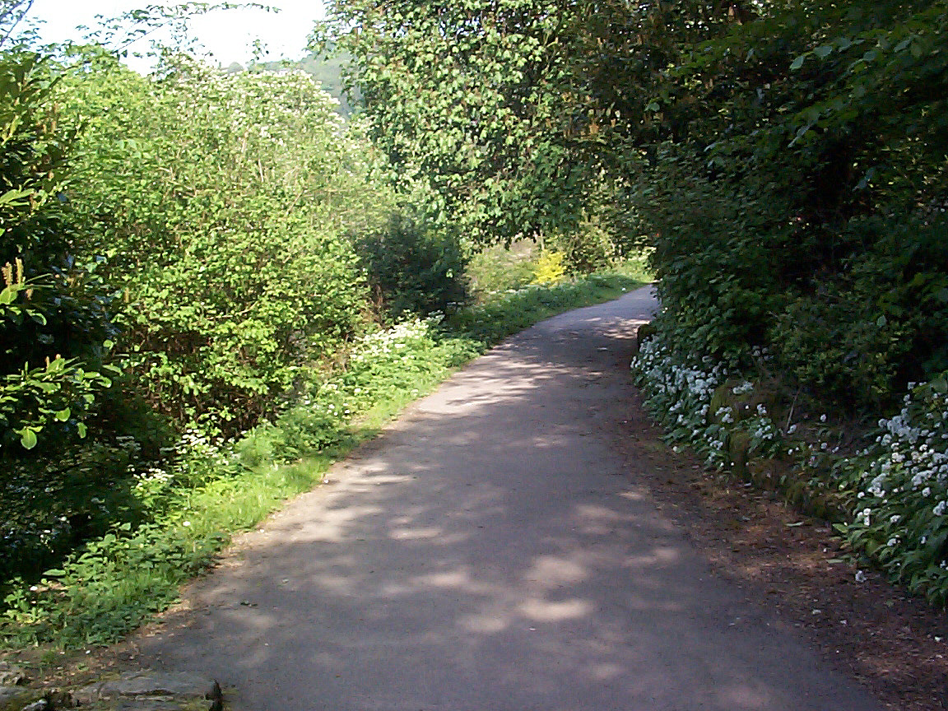
Consensus Worksheet A
Complete the tasks on this side, and while you are watching, make a note on the other side of this sheet of useful words and phrases that can be used to keep the discussion or debate going, or to put across a point of view.

How does the discussion begin in a way that shows respect for everyone involved?

How do the participants demonstrate that reaching consensus is more important than their own personal point of view? How do they show dignity and community mindedness?

How do the participants contribute to what others say? What is the effect of this?

How does everyone get an equal say? How is respect shown to each other?

How do they reach agreements? How does this show community mindedness?

How can you do this in your own debate?

Consensus Worksheet B

How does the discussion begin? How does this show respect?

How do people speak to each other? How does this show dignity?

How do people show that they want to hear the other people’s points of view?

How do they show that they all want to achieve the same things? How is this community minded?

How do they keep the debate going and learn from each other? How does this show perseverance?

How can you do this in your own debate?
Win-win sheet

What are our main points?

What would we be willing to give up to achieve the best outcome for the community?

What could they give up to achieve the best outcome for us?

What would be the benefit of this?

Win-win sheet

What are our main points?

What would we be willing to give up to achieve the best outcome for the community?

What could they give up to achieve the best outcome for us?

What would be the benefit of this?

Self/ peer assessment
Give this sheet to your two observers. They make notes in the first two columns while you debate. Afterwards you complete the third column, using their notes.

Peer assessment - Which virtue did they use? | Peer assessment - How did they use it? Give an example | Self assessment – what was the outcome of that? What did it achieve in the discussion?

