Year 7
Character and Wellbeing Workbook

Being a Good Neighbour

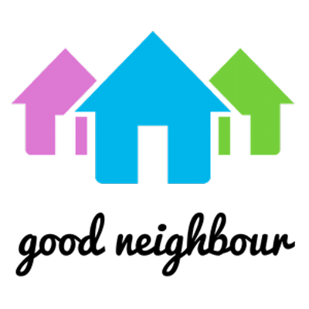
Lesson Progress

- What makes a good neighbour?

- How can I be a good neighbour?

- What influences me being a good neighbour?

- Random Acts of Kindness

- Anti-Bullying and Neighbourliness

Lesson 1 - What makes a good neighbour?
Learning objectives:
- Define what a neighbour is
- Identify and prioritise character qualities of a good neighbour
- Describe which qualities make the best neighbour

Starter
Task: Study the image below and write the first 5 words that you think of.
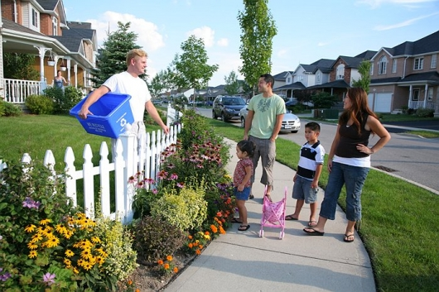

Challenge: Which of your words best sums up the picture? Why?
……………………………………………………………………………………………………………………………………………………………………………………………………………………………………………………………………………………………………….

Main Activity 1
Mind-map the different types of neighbours (people) they may have in life. Home, school, wider community.
Stretch: Colour-code them according to how often you see them – daily, weekly, monthly, less-often

Challenge: Explain which type of neighbour is the most important to you and why.
………………………………………………………………………………………………………………………………………………………………………………………………………………………………………

Main Activity 2
Using the qualities of a good neighbour, prioritise them using the Diamond 9 template.
Stretch: Explain why you have chosen your most and least important ones.
I have chosen …………………………….. as my most important quality because …………………………………………………………………………………………………………………………………………………………………………………………………….
I have chosen …………………………….. as my least important quality because …………………………………………………………………………………………………………………………………………………………………………………………………….
Respectful
Considerate
Ready to help
Friendly
Help build relationships
Communicate
They promote wellbeing
They obey the law
Caring

Challenge: If you had to add 3 more qualities on to our list which three would you add and why?

Plenary – Reflection
In your opinion, who would be the best neighbour for you? Why?

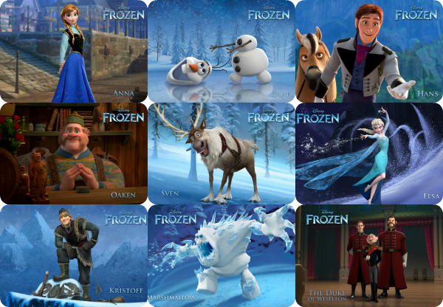

The best neighbour for me would be …………………………………… because… …………………………………………………………………………………………………………………………………………………………………………………………………….

Lesson 2 - How can I be a good neighbour?
Learning objectives:
- Identify one way in which I can improve my qualities to be a good neighbour
- Explain how I can be a good neighbour
- Analyse situations to give the best outcome as a good neighbour

Starter
Study the Word Cloud. Which words appear biggest? What do these words mean? Do these words link to what we have been learning about neighbours?
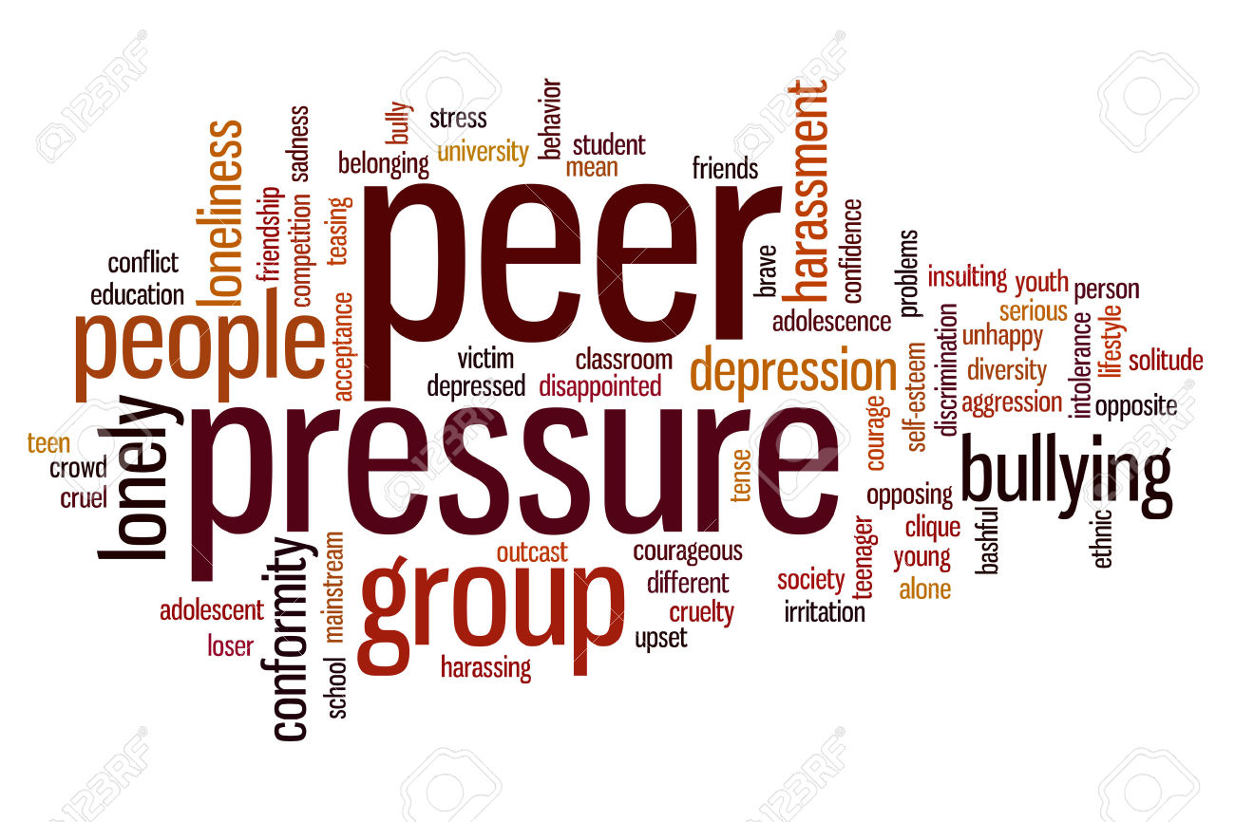
Word that appears big | What it means | How it links to neighbours
Example: Lonely | When someone feels alone. | Good neighbours don’t let others feel alone.

Main Activity
Read the story of Ilan Halimi.
Alan Halimi was kidnapped in Paris and tortured for 24 days, finally dying on February 13. During this time, his kidnappers, at least 20 of them, beat him all over his body except for his mouth, so he could breathe and eat, stabbed him, burned his body and face with lighters and cigarettes, and broke his fingers in order to get a ransom from his family.
During these three weeks, neighbours in the apartment block where his kidnappers had taken him (and where they lived) heard the what was happening and came to watch. No one ever called the police. 27 people have so far been sent to prison because of joining in. One of the torturer’s fathers knew what was happening and did nothing to stop them.
Those neighbours known only to have watched were not sent to prison. Alan was found handcuffed and bound with rope to a tree about 40 yards inside a woodland outside Paris.

Why do you think people didn’t help?
……………………………………………………………………………………………………………………………………………………………………………………………………………………………………………………………………………………………………….
What would you have done in this situation?
………………………………………………………………………………………………………………………………………………………………………………………………………………………………………………………………………………………………………

Plenary – Reflection
Choose 2 of the words below and explain how each one links to today’s lesson:

Word 1: ……………………………………
This links to today’s lesson because ………………………………………………….. ………………………………………………………………………………………………….
Word 2: ……………………………………
This links to today’s lesson because ………………………………………………….. ………………………………………………………………………………………………….

Lesson 3 – What influences me being a good neighbour?
Objectives:
- Identify positive and negative influences on being a good neighbour
- Describe ways in which we can be influenced being a good neighbour
- Explain how to overcome negative influences on being a good neighbour

Main Activity 1
Adapted from Young Citizens, Save the Children 2002
Read through Dennis’ story. Highlight in negative influences in one colour and positive influences in another colour.

“I live in Honduras, with my older brother and my mother. My neighbourhood is very dangerous. There are lots of gangs. They have fights between each other and hurt other people. Many parents worry that their children will not be safe in the streets and so they do not let them out so often.
I started going to church when I was six years old. Through this, I began helping children in my neighbourhood. My family also got involved with a community group that helped us a lot.
My neighbourhood is a poor one. Families have moved here from the countryside to make a better living. But there are problems. The government isn’t interested in communities like this. We don’t have clean water. The drains are very unhealthy. Sometimes people complain that the government doesn’t help, but there are things we can do ourselves to keep the community united.
For me, poverty is something very ugly. It stops you doing what you dream of. Poverty means a lot of people don’t have money to buy food. Seeing it around makes me feel bad.
I’m lucky. Thanks to my mum, I’ve been able to go to school. But many children where I live don’t have the same chance. They don’t have enough money to pay for the fees and uniforms. They feel terrible when they see other children going past on their way to school. They ask, “Why can’t I study too?”
I wanted to do something because I know what poverty is like. I began to teach children to read and write. Ten children came at first. Now I hold classes every day of the week. I also teach children about their rights. If you know what your rights are, you can speak up if you see something that’s bad. Our community group helps me with my teaching. We are also planning to start a canteen for children whose families do not have enough money to buy food.
All this has changed me, have learned to understand people, especially children. They tell me what’s bothering them and I try to give advice. I would like other children to have good lives, to be able to learn and to have all their rights fulfilled.”
Main Activity 2
Adapted from Young Citizens, Save the Children 2002
Using the donut diagrams, analyse who influences you in both positive and negative ways and also how you can influence them as a neighbour.

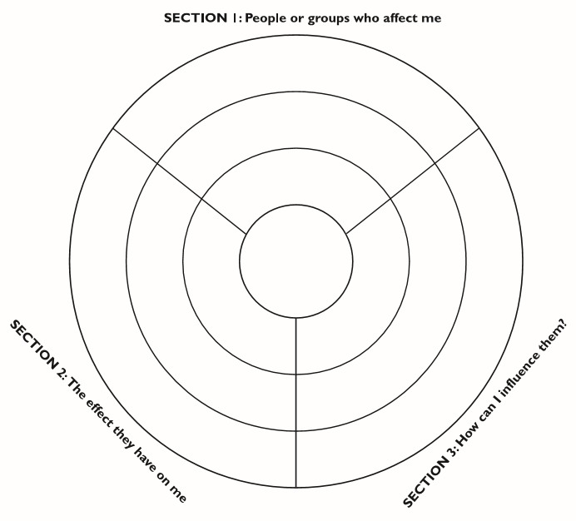
Family and friends
Nationally
Locally and Community
Challenge: Explain whether someone nationally, locally or your family and friends have more of an influence on you. Why do you think this is?
………………………………………………………………………………………………………………………………………………………………………………………………………………………………………………………………………………………………………

Plenary – Reflection
Complete the grid below with your thoughts from today’s lesson.
Head: Something that has made you think  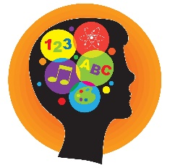 | Heart: A feeling/emotion you have felt
Bin: Something you did not find interesting  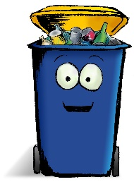 | Bag: Something you will take away and remember  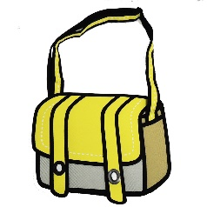

Lesson 4 – Random Acts of Kindness
Lesson objectives:
- Describe what others do to be kind.
- Explain how this can affect others.
- Evaluate whether people are kinder to one group of people more than others
Starter
Read the quote from Princess Diana.
What do you think it means?
……………………………………………………………… ……………………………………………………………… ……………………………………………………………… ………………………………………………………………
What do you think she meant when she said “with no expectation of reward”?
……………………………………………………………………………………………………………………………………………………………………………………………………
Stretch: What makes an act of kindness random?
……………………………………………………………………………………………………………………………………………………………………………………………………

Main Activity
Discuss and number the below in terms of how kind they are.
(1 = not kind > 10 = extremely kind)
 | Rating out of 10 with a reason why you have given it this rating. | What could make this act even kinder? | Is there anything you would expect in return for doing this? What would it be?
Help someone with a disability.
Steal a charity donation to pay for something for someone else.
Pick up someone else’s money after they’ve dropped it.
Send someone else’s wallet back to them in the post.

Stretch: I think it is important to be kind in public because……………………… ………………………………………………………………………………………………..
Challenge: I would/would not expect something in return for completing an act of kindness because………………………………………………………………….. ………………………………………………………………………………………………….
Plenary – Reflection
What can you take from today’s lesson to help you?
…………………………………………………………………………………………………………………………………………………………………………………………………………………………………………………………
What can you take from today’s lesson to help others?
………………………………………………………………………………………………………………………………………………………………………………………………………………………………………………………...
How can we be kinder in today’s society?
…………………………………………………………………………………………………………………………………………………………………………………………………………………………………………………………

Lesson 5 – Bullying and Neighbourliness
Lesson objectives:
- Define what gossip and bullying is
- Describe the ways in which bullying can affect people
- Explain how gossiping and bullying can affect neighbourliness
Starter
Watch the Harry Potter clip: http://www.youtube.com/watch?v=5YP3PWYEyBU
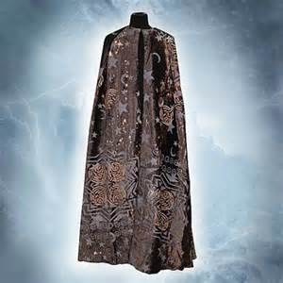
What would you do if you had a cloak of invisibility?
…………………………………………………… …………………………………………………… …………………………………………………… …………………………………………………… ……………………………………………………
Would you use your invisibility for good or for bad? Why?
………………………………………………………………………………………………………………………………………………………………………………………………………………………………………………………………………………………………………

Main Activity 1
Think, pair, share:
Question | What do you think? | What do you think as a pair? | What would you like to share?
How is being online similar to being invisible?
Which qualities would you like people to be able to see that you have or don’t have?
Do neighbours always have to be angels?

Main Activity 2
“An internet 'troll' is a rude or horrible user who uses shock to help fights and conflict in online groups.”
Have you ever experienced or come across this with your internet use?
………………………………………………………………………………………………………………………………………………………………………………………………………………………………………………………………………………………………………

Look at the following stories and consider:
- How do they demonstrate non-neighbourliness?
- How could someone being a good neighbour help the situation?
Story 1
Sean Duffy was jailed for 18 weeks for posts on social networking sites about a 15-year-old after she took her own life.
Story 2
MP Karen Bradley raised trolling in Parliament after a Facebook page was set up making fun of a 17-year-old's death in a car crash.
Story 3
Colm Coss was jailed for 18 weeks after posting obscene messages on Facebook sites set up in memory of the Big Brother star and several other dead people.

Plenary – Reflection
- I have posted something horrible on a social network site before
- Before today’s lesson, I didn’t think about the effects of posting negative things on social networks
- After today’s lesson, I am going to think twice before posting negative things on social networks
- I know how to report issues of cyberbullying on websites

